

presents

FOREIGN STUFF
(Roba Forestiera)

A documentary by Silvia Holzinger and Peter Haas

FOREIGN STUFF (Roba Forestiera)– Credits

A/D 2004, DV-PAL, colour, 44min.

Idea: Silvia Holzinger

Directors: Silvia Holzinger, Peter Haas

Photography: Peter Haas

Sound: Peter Haas

Editing: Silvia Holzinger, Peter Haas

Music: UARAGNIAUN, www.uaragniaun.com

Cast: Sara Stramiello, Vito Guida, Ralf Koslowski a.o.

Production: Il Mare Film

Distribution: Il Mare Film, www.ilmarefilm.org

Format: DV-PAL on DVD or Beta-SP

Language: German/Italian, English subtitles or Italian or German subtitles

Synopsis:
FOREIGN STUFF is a portrait of Sassi di Matera, in southern Italy, an almost forgotten, labyrinthine town, dug into the cliffs that has existed since Classical times and is nearly uninhabited today. Pasolini created ìThe Gospel according to St. Matthewî in the Sassi in 1964 and was inspired by this unique place. Encounters with Sara, Vito and Ralf, who still live in the Sassi. Ralf is a sculpturist specialized in tuff stone craftsmanship. He rebuilds tuff stone houses in balance with nature. Vito was born in a cave…but in 1953 Sassi were highly overpopulated and evacuated. A surprise with the bewitching music of an Apulian singer. What will happen to this town in the future?

Director statement:
The question that was finally posed to us was what will happen to this town? Will it be transformed into a museum of dead stone, or into another small living town in the future?
During the weeks in the Sassi di Matera it became obvious to us that with the evacuation an entire society vanished. Obviously, a lot of skills of creating and maintaining tuff houses have also been lost.

We didnít want to deal with any officials, politicians or other authorities. It was not about the 167 official churches of the town, which was made a UNESCO World Heritage Site in 1993. We were looking for the unexpected, for mystery.
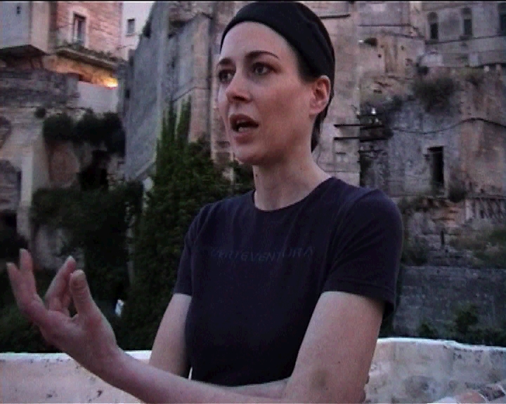

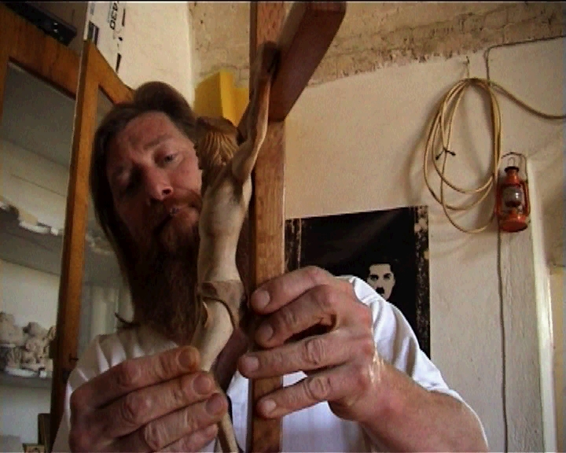

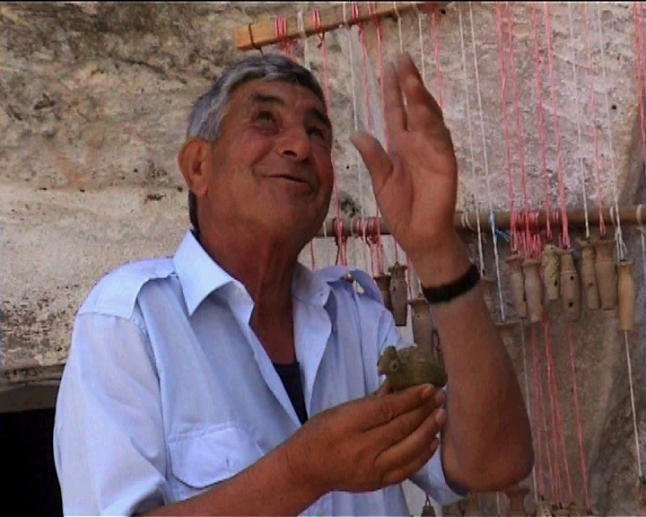
PRESS RELEASE Vienna, March 22 2005

Foreign Stuff – Festival Submission to the 7th Thessaloniki Documentary Festival –
Images of the 21st Century, 1- 10.4.2005, Thessaloniki, Greece.
Debut Documentary Film by Silvia Holzinger and Peter Haas

The 44-minute long documentary “Foreign Stuff” (Roba Forestiera) is the first film by the Austrian-German team “Il Mare Film” to be shown in Greece. The film will be shown at the seventh Thessaloniki Documentary Festival this year, with screenings on April 2 at 4 o’ clock at the John Cassavetes Theatre and on April 4 at 7 o’ clock at the Stavros Tornes Theatre. Il Mare Film is also represented at the International Doc Market. The documentary portrays the Sassi of Matera, a remote and decaying town carved into tuff rock in the Basilicata in the South of Italy.

In conversations and interviews with unusual and original inhabitants of Matera, a lively portrait of the town is created that captures the magic and mystery of the place. There is Vito, who was born in a tuff cave. Ralf who came to Matera as a young man in 1980, stayed, restored a house that was falling down, and who has lived there since working as an artisan and artist. And there is Massimo who was so inspired by Matera that he founded a theatre there.

The Sassi have a unique appeal because of the fact that these Stone Age caves, which developed into tuff houses and were lived in until 1953, have been occupied for millennia, something that has drawn many filmmakers to Matera. Pasolini’s “The Gospel According to St. Matthew” and Mel Gibson’s “The Passion of the Christ” were both filmed there. Foreign Stuff accompanies a group of young people in Matera as they organise an exhibition about the making of the Pasolini film.

The audience is treated to an opulent and surprising vision of tuff-coloured pictures, the constant sound of rare hawks, the picture-perfect view of the Sassi and the Gravina gorge. The beguiling music in the film is provided by UARAGNIAUN, who use ancient restored instruments to play tunes from Murgia and the Gravina, helping to make the film a highly unusual and independent submission – or perhaps just an improvisation about the passing of time in film form.

About Il Mare Film –
Il Mare Film was founded by Silvia Holzinger and Peter Haas in Vienna in 2002. It is a collaboration of this Austrian-German team, and works exclusively with digital film. Il Mare produces films independently, FOREIGN STUFF is also entirely self-financed. Both filmmakers have taken part in film festivals in Germany, Austria and Italy, and hope to use the 7th Thessaloniki Film Festival to make direct contact with International TV channels in order to have an opportunity to show their film to international TV audiences. Press contact - +43 1 9133 925, or e-mail pr@ilmarefilm.org Website in English, German and Italian at http://www.ilmarefilm.org
Festivals presenting “FOREIGN STUFF” (Roba Forestiera)

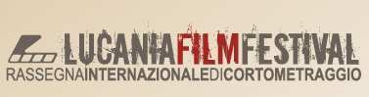

Lucania Film Festival, Matera, Italy, 07/2004.

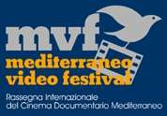

Rassegna Internazionale del Cinema Documentario nel Mediterraneo, Ascea Marina (SA),Italy, 09/2004.



Biberacher Independent Film Festival B.I.F.F., Biberach, Germany, 11/2004, “Honourable Mention” for Roba Forestiera/FOREIGN STUFF.



DIAGONALE 2005, Festival des österreichischen Films, Vienna, Austria,
14.-20. April 2005

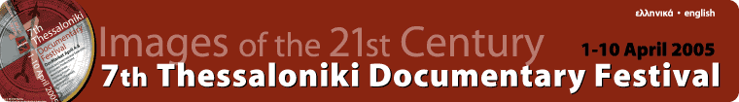

Thessaloniki International Film Festival, Thessaloniki, Greece, 1.-10.4.2005

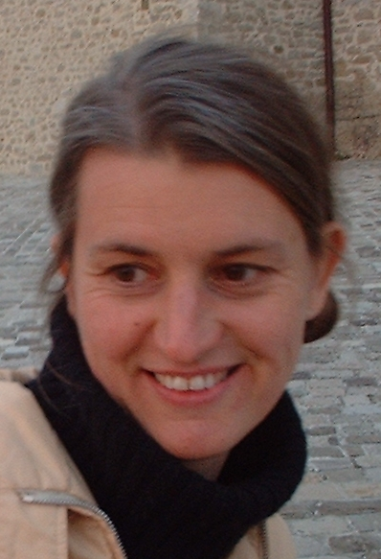

Silvia Holzinger :

Silvia was born in Upper Austria in 1966, studied Communication Studies and Italian Literature in Vienna, Berlin and Rome. She wrote her master thesis on the one-man cinema of the Roman film-maker, Nanni Moretti. She has worked in various roles in a variety of projects involving films, film festivals, workshops, and a production handbook. In 2002 she graduated from the School of Digital Video work at the Videolab in Vienna. The documentary film-makers Ferdinand Stahl, Karin Berger, Käthe Kratz and Ebba Sinzinger were her mentors as well as Vincent Lucassen.

Selection of films/videos:
“Ein Silberstreif am Horizont”, 30min., 2002,
“Kohlgasse 19 / Schmuckwerkstatt”, 18min., 2001

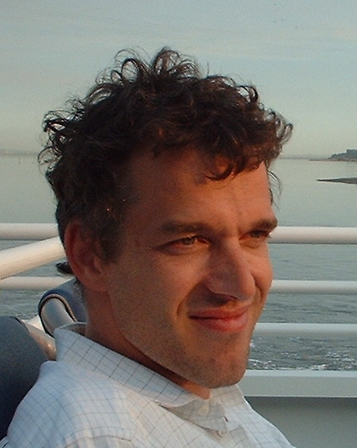

Peter Haas:

Peter Haas was born in Osnabrück in 1965. He studied Philosophy and German Literature in Cologne, Vienna and Berlin. After dropping out, as a passionate nerd, he could only really get into film with the advent of FireWire and DV.

Peter started his own software company in 1990, mainly developing communication software. In 2000, he started Weblicon Technologies AG, a mobile software company. He raised more than $4m of Venture Capital and managed to grow the company to more than 25 employees in 2004. Weblicon was acquired in 2005 and Peter resigned as CEO.

Peter believes in the paradigm shift from traditional, “chemical” film-making to digital movies and favors an all-digital production cycle for documentary film-making and distribution.

The making of FOREIGN STUFF

Silvia Holzinger was inspired by the Italian film-maker Nanni Moretti, who started his career with what Silvia Holzinger named the 1-man-cinema in her master thesis 1997.

Together with Peter Haas, IL MARE FILM was founded in 2002, and still is a one-woman-and-one-man-cinema. FOREIGN STUFF was completely developed, shot and produced by the two film-makers, financing of the project was independent.

In 2003, the documentary was shot within 16 days in Matera, Basilicata. The film-makers did not know anyone in Matera, all protagonists were contacted on site and many of them became friends.

“We took the risk to go to Matera and to develop the entire documentary on-the-fly, without knowing who might support us. The openness of local contributors was overwhelming. Without taking the risk of improvisation, many of the most impressive scenes would not have been possible.” says Silvia Holzinger.

“The result was less than 10 hours footage, shot in the Sassi di Matera. We have tried to avoid shooting in-house, mainly due to our simple MiniDV camera. Daylight and the characteristic tuff-stone colors as well as the weather conditions made it possible to shoot with a simple consumer camera. The small camera was advantageous while shooting inside the caves.” says Peter Haas.

While editing the footage, the film-makers tried to avoid the TV-style voice-over commentary. On the contrary, interviewers and protagonists remained both visible preserving all the contradictions different protagonists came up with and contributing to what created tension.

“There is no neutral way to portrait a place such as the Sassi di Matera. We have come with our own ideas and our mind set, therefore, it would have been artificial and misleading pretending an equally balanced documentary. Our strength is to create an intimate atmosphere and a relationship with our protagonists, we will rely on that next time.”

IL MARE FILM is currently developing a new project and wants to appeal international TV stations. IL MARE FILM strongly believes in the
paradigm shift that affects the production of documentaries and favors an all-digital production and distribution cycle.

Keep an eye on us and make yourself a bookmark.
http://www.ilmarefilm.org
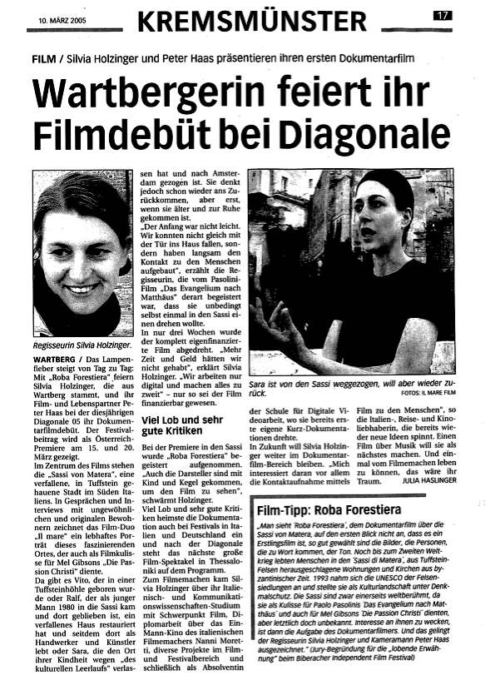

Novembre, 8th 2004, B.I.F.F. Biberacher Independent Film Festival, Germany, 2004

Roba Forestiera received HONOURABLE MENTION!

Sonntag, den 8. November 2004 wurde ROBA FORESTIERA im Rahmen des Biberacher Independent Film Festivals erstmals in Deutschland aufgeführt. Uli Stöckle und Dierk Andresen, die Festival-Organisatoren:

Lobende Erwähnung für "Roba Forestiera" von Silvia Holzinger und Peter Haas Die Begründung der Jury

Man sieht ¨Roba Forestiera¨, dem Dokumentarfilm über die Sassi von Matera,
auf den ersten Blick nicht an, dass es ein Erstlingsfilm ist, so gut gewählt
sind die Bilder, die Personen, die zu Wort kommen und der Ton. Noch bis zum
Zweiten Weltkrieg lebten Menschen in den ¨Sassi di Matera¨, aus
Tuffstein-Felsen herausgeschlagene Wohnungen und Kirchen aus byzanti-
nischer Zeit, in erbärmlichen hygienischen Verhältnissen.
1993 nahm sich die UNESCO der Felsensiedlungen an und stellte sie als
Kulturlandschaft unter Denkmalschutz. Die Sassi sind zwar einerseits
weltberühmt, da sie als Kulisse für Paolo Pasolinis ¨Das Evangelium nach Matthäus¨ und auch für Mel Gibsons ¨Die Passion Christi¨ dienten, aber letztlich doch unbekannt. Interesse an ihnen zu wecken, ist dann die Aufgabe des Dokumentarfilmers. Und das gelingt der Regisseurin Silvia Holzinger und Kameramann Peter Haas ausgezeichnet.

In den Interviews mit Alteingesessenen, Zugewanderten und Heimkehrern wird die jüngere Historie des Ortes ebenso deutlich wie seine problematische Zukunft. Der Ort blutet aus, Läden sind nicht mehr zu finden und dennoch ziehen Menschen (wieder) her, entdecken ihre Wurzeln neu oder geniessen als Künstler und Handwerker die Atmosphäre. Und eben diese Atmosphäre vermittelt der Film auch mit vielen stillen Momenten, die dem Auge Zeit lassen, zu schauen, ohne ablenkenden Kommentar. Man merkt, dass Silvia Holzinger sich in Italien auskennt und es liebt. Wenn die weiteren Arbeiten der beiden Filmemacher ihren Sujets so gerecht werden, wie es ¨Roba Forestiera¨ tut, dann darf man sich auf diese Filme freuen. Die lobende Erwähnung ist verdient; dass sie auf einem Festival verliehen wurde, dass seine deutliche Präferenz bei no budget und low budget Produktionen hatte, belegt deutlich, dass der Film die Jury beeindruckte. Der Beifall des Publikums und auch dessen Äusserung nach den Vorführungen des Films, die immer wieder hervorhoben, wie gut der Film die einzigartige Atmosphäre des Ortes vermittelte, bestätigten diese Entscheidung.

(von Dierk Andresen, Uli Stöckle, B.I.F.F.)
Copyright: Wiener Zeitung | Erschienen am: Freitag, 18. März 2005

Zwischenbericht von der Diagonale in Graz, dem Festival des österreichischen Films

Alles, was auf die Leinwand passt

Von Lona Chernel, Graz

Überangebot bei der Diagonale in Graz: Man weiß nicht, wo man zuerst sein soll. Es wird eine derartige Fülle an Kurzfilmen, Dokumentationen, Experimentalfilmen und dazu noch eine Reihe hochinteressanter Rahmenprogramme angeboten, dass man am liebsten an mehreren Orten gleichzeitig wäre.

Spannend und bewegend etwa ist die Dokumentation "Roba Forestiera" von Silvia Holzinger und Peter Haas. Die beiden entführen die Zuschauer in die Sassi von Matera, eine vor über tausend Jahren in den Tuffstein gehauene Stadt in Süditalien, die heute fast ausgestorben ist. Jetzt versuchen Künstler die Sassi, wo bereits Pasolini gedreht hat, wieder zu beleben. Wunderbare Bilder und informative Interviews bringen einem die berückend schöne Gegend und ihre Probleme ganz nahe.

…
…

Copyright: Wiener Zeitung | Erschienen am: Freitag, 18. März 2005

